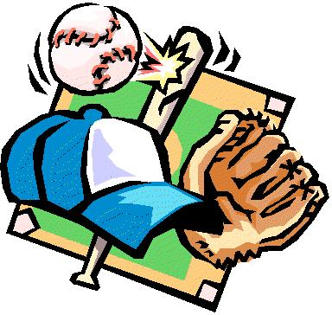

REGISTER FOR BASEBALL & SOFTBALL AT OSHKOSH CITYHALL. THE FEE IS $20 PER CHILD. PLEASE PAY AT THE TIME OF REGISTRATION. CITY HALL, 772-3686.

BASEBALL/SOFTBALL DIRECTOR: ROGER APPLE, 772-9998.

